Introduction

What is Programming?
Just like we use Hindi or English to communicate with each other, we use a Programming language to communicate with the computer.
Programming is a way to instruct the computer to perform various tasks.

What is Python?
Python is a simple and easy-to-understand language that feels like reading simple English. This Pseudo code nature of Python makes it easy to learn and understandable for beginners.

Features of Python:
- Easy to understand = Less development time
- Free and open source
- High-level language
- Portable – works on Windows/Linux/Mac
- + Fun to work with :)

Chapter 1: Modules, Comments & Pip
Let’s write our very first python program.
Create a file called hello.py and paste the below code into it
print(“Hello World”) # print is a function (more later)
Copy
Execute this file (.py file) by typing python hello.py, and you will see Hello World printed on the screen.
Modules
A module is a file containing code written by somebody else (usually) which can be imported and used in our programs.
Pip
Pip is a package manager for python. You can use pip to install a module on your system.
E.g., pip install flask (It will install flask module in your system)
Types of modules
There are two types of modules in Python:
- Built-in modules – Pre-installed in Python

Examples and systax
import os
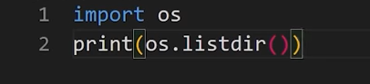

#importing the os module
import os

#to get the current working directory
directory = os.getcwd()

print(directory)

If you want import specific part to module and not whole module, then use below syntax
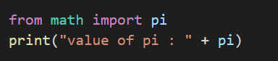

- External modules – Need to install using pip
pip install flask

Some examples of built-in modules are os, abc, etc.
Some examples of external modules are TensorFlow, flask, etc.
Using Python as a Calculator
We can use python as a calculator by typing “python” + TO DO on the terminal. [It opens REPL or read evaluation print loop]
Comments
Comments are used to write something which the programmer does not want to execute.
Comments can be used to mark the author's name, date, etc.
Types of Comments:
There are two types of comments in python,
- Single line comments – Written using # (pound/hash symbol)
- Multi-line comments – Written using ‘’’ Comment ‘’’ or “”” Comment “””.
Chapter 1 – Practice Set
- Write a program to print * pattern in python.
*
**
***
****
*****

- Use REPL and print the table of 5 using it.
- Install an external module and use it to perform an operation of your interest. (External module)
Import some module and play song with code
- Write a python program to print the contents of a directory using os module. Search online for the function which does that. (internal Module)
- Label all above program with comments.

Chapter 2 – Variables and Data Types
A variable is a name given to a memory location in a program. For example
a=30

b=”Harry”

c=71.22
d = True
d=False
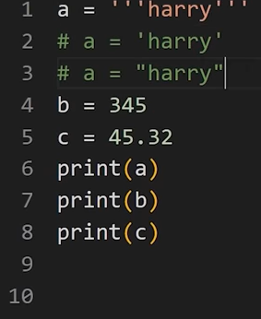

Variable – Container to store a value
Keywords – Reserved words in Python
Identifiers – class/function/variable name
Data Types:
Primarily there are the following data types in Python:
- Integers
- Floating point numbers
- Strings
- Booleans
- None
Python is a fantastic language that automatically identifies the type of data for us.
a = 71 #Identifies a as class<int>

b = 88.44 #Identifies b as class<float>

name = “welcome” #Identifies name as class<Str>

Rules for defining a variable name: (Also applicable to other identifiers)
- A variable name can contain alphabets, digits, and underscore.
- A variable name can only start with an alphabet and underscore.
- A variable can’t start with a digit.
- No white space is allowed to be used inside a variable name.
- Variable names are case sensitive
Examples of few valid variable names,
abc, name, one8, _akki, aakash, _bro, etc.
Operators in Python
The following are some common operators in Python:
- Arithmetic Operators (+, -, *, /, etc.)
- Assignment Operators (=, +=, -=, etc.)
- Comparison Operators (==, >=, <=, >, <, !=, etc.)
- Logical Operators (and, or, not)
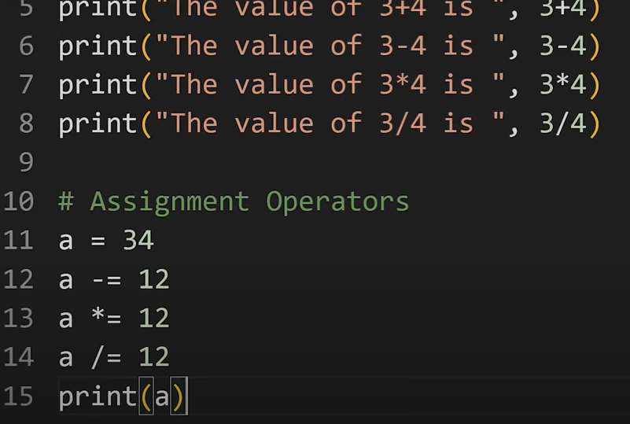

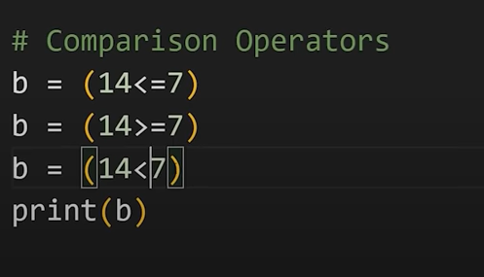

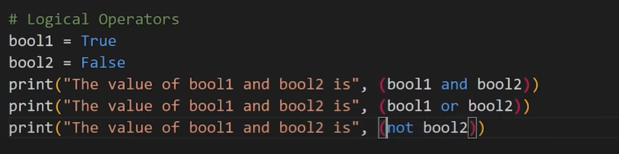
type() function and Typecasting
type function is used to find the data type of a given variable in Python.
a = 31

type(a) #class<int>

b = “31”

type(b) #class<str>

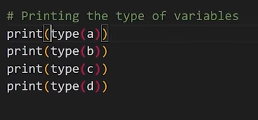

Typecasting –

A number can be converted into a string and vice versa (if possible)
There are many functions to convert one data type into another.
Str(31) # ”31” Integer to string conversion

int(“32”) # 32 String to int conversion

float(32) #32.0 Integer to float conversion

Here “31” is a string literal, and 31 is a numeric literal.

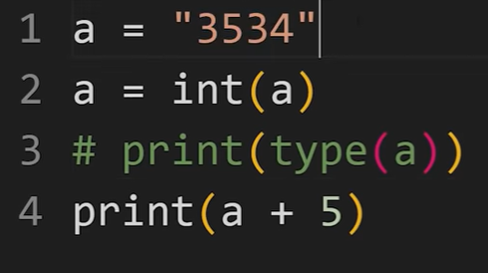

input() function
This function allows the user to take input from the keyboard as a string.
a = input(“Enter name”) #if a is “sagar”, the user entered sagar
Note: The output of the input function is always a string even if the number is entered by the user.
Suppose if a user enters 34, then this 34 will automatically convert to “34” string literal.

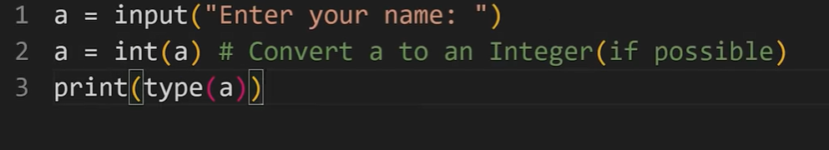

Chapter 2 – Practice Set
- Write a Python program to add two numbers.
- Write a Python program to find the remainder when a number is divided by Z(Integer).
- Check the type of the variable assigned using the input() function.
- Use a comparison operator to find out whether a given variable a is greater than b or not. (Take a=34 and b=80)
- Write a Python program to find the average of two numbers entered by the user.
- 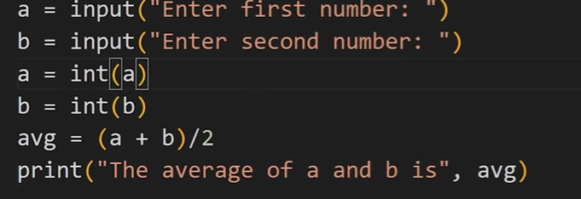

- Write a Python program to calculate the square of a number entered by the user.

Chapter 3 – Strings
The string is a data type in Python.
A string is a sequence of characters enclosed in quotes.
We can primarily write a string in three ways:
- Single quoted strings : a = ‘welcome’
- Double quoted strings : b = “welcome”
- Triple quoted strings : c = ‘’’welcome‘’’
String Slicing:
A string in Python can be sliced for getting a part of the string.
Consider the following string:
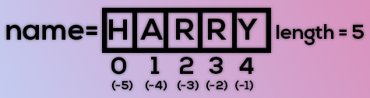
The index in a string starts from 0 to (length-1) in Python. To slice a string, we use the following syntax:
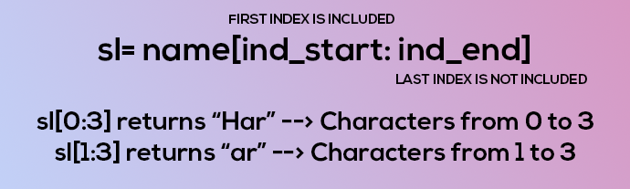
Negative Indices: Negative indices can also be used as shown in the figure above. -1 corresponds to the (length-1) index, -2 to (length-2).
Slicing with skip value
We can provide a skip value as a part of our slice like this:
word = “amazing”

word[1:6:2] # It will return ’mzn’
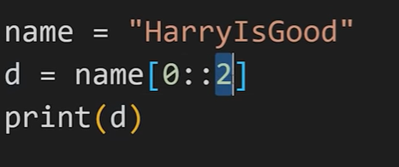

Other advanced slicing techniques
word = ‘amazing’

word[:7] or word[0:7] #It will return ‘amazing’

word[0:] or word[0:7] #It will return ‘amazing’

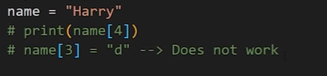

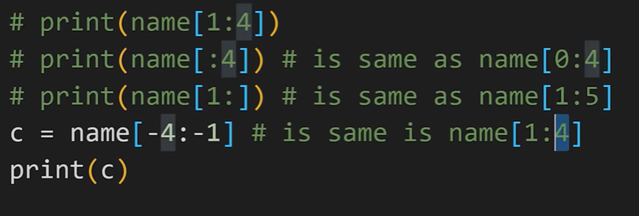
String Functions
Some of the most used functions to perform operations on or manipulate strings are:
- len() function : It returns the length of the string.
len(‘harry’) #Returns 5
- endswith(“rry”) : This function tells whether the variable string ends with the string “rry” or not. If string is “harry”, it returns for “rry” since harry ends with rry.
- count(“c”) : It counts the total number of occurrences of any character.
- capitalize() : This function capitalizes the first character of a given string.
- find(word) : This function finds a word and returns the index of first occurrence of that word in the string.
- replace(oldword, newword) : This function replaces the old word with the new word in the entire string.
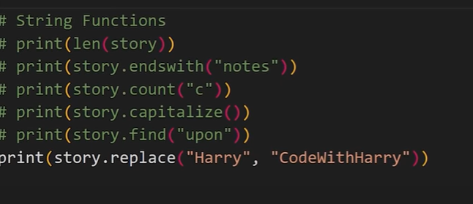
Escape Sequence Characters:
Sequence of characters after backslash ‘\’ [Escape Sequence Characters]
Escape Sequence Characters comprises of more than one character but represents one character when used within the string.
Examples: \n (new line), \t (tab), \’ (single quote), \\ (backslash), etc.
Chapter 3 – Practice Set
- Write a Python program to display a user-entered name followed by Good Afternoon using input() function.
- Write a program to fill in a letter template given below with name and date.
letter = ‘’’ Dear <|NAME|>,

You are selected!

<|DATE|>
Copy
- Write a program to detect double spaces in a string.
- Replace the double spaces from problem 3 with single spaces.
- Write a program to format the following letter using escape sequence characters.
letter = “Dear Harry, This Python course in nice. Thanks!!”

Chapter 4 – Lists and Tuples
Python Lists are containers to store a set of values of any data type.
friends = [‘Apple’, ‘Akash’, ‘Rohan’, 7, False]

The list can contain different types of elements such as int, float, string, Boolean, etc. Above list is a collection of different types of elements.
List Indexing
A list can be index just like a string.
L1 = [7, 9, ‘harry’]

L1[0] – 7

L1[1] – 9

L1[70] – Error

L1[0:2] – [7,9] (This is known as List Slicing)

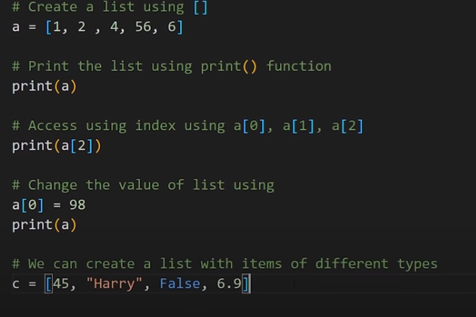
List Methods
Consider the following list:
L1 = [1, 8, 7, 2, 21, 15]
Copy
- sort() – updates the list to [1,2,7,8,15,21]
- reverse() – updates the list to [15,21,2,7,8,1]
- append(8) – adds 8 at the end of the list
- insert(3,8) – This will add 8 at 3 index
- pop(2) – It will delete the element at index 2 and return its value
- remove(21) – It will remove 21 from the last
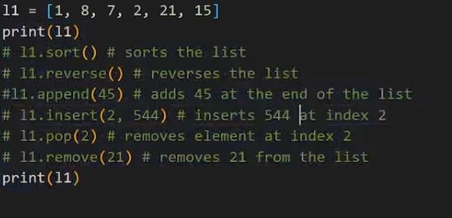

Tuples in Python:
A tuple is an immutable (can’t change or modified) data type in Python.
a = () #It is an example of empty tuple
a = (1,) #Tuple with only one element needs a comma
For example, when connecting multiple tuples with + operator, note that if you try to add one element and forget a comma ,, an error will occur.
# print((0, 1, 2) + (3)) #invalid
# TypeError: can only concatenate tuple (not "int") to tuple

print((0, 1, 2) + (3, )) # valid
# (0, 1, 2, 3)

a = (1, 7, 2) #Tuple with more than one element

Once defined, tuple elements can’t be manipulated or altered.

The reason why you need a comma , for a single tuple is that "tuple is an object delimited by comma ,", not "an object enclosed in parentheses ()".
Note that it is actually the comma which makes a tuple, not the parentheses. The parentheses are optional, except in the empty tuple case, or when they are needed to avoid syntactic ambiguity. but are required when creating an empty tuple.
Tuple parentheses are basically optional
a = 1, 7, 2 # is also valid tuple

Code Sample for empty tuple
empty_tuple = ()

print(empty_tuple)
print(type(empty_tuple))
# ()
# <class 'tuple'>

# empty_tuple_error =
# SyntaxError: invalid syntax

# empty_tuple_error = ,
# SyntaxError: invalid syntax

# empty_tuple_error = (,)
# SyntaxError: invalid syntax

An empty tuple can also be created with tuple() without an argument.

empty_tuple = tuple()

print(empty_tuple)
print(type(empty_tuple))
# ()
# <class 'tuple'>

Tuples in function arguments

If there is a syntactic ambiguity, tuples require parentheses ().
Multiple arguments are specified by separating them with a comma ,. If you want to specify a tuple as one argument, parentheses () are required.
Without parentheses (), each value is passed to each argument, and with parentheses (), a tuple is passed to one argument.

def example(a, b):
print(a, type(a))
print(b, type(b))

example(0, 1)
# 0 <class 'int'>
# 1 <class 'int'>

# example((0, 1))
# TypeError: example() missing 1 required positional argument: 'b'

example((0, 1), 2)
# (0, 1) <class 'tuple'>
# 2 <class 'int'>

If you add * to the tuple, you can unpack the tuple and pass each element to each argument.
example(*(0, 1))
# 0 <class 'int'>
# 1 <class 'int'>

Tuple methods:
Consider the following tuple,
a = (1, 7, 2)
Copy
- count(1) – It will return the number of times 1 occurs in a.
- index(1) – It will return the index of the first occurrence of 1 in a.
Chapter 4 – Practice Set
- Write a program to store seven fruits in a list entered by the user.
- Write a program to accept the marks of 6 students and display them in a sorted manner.
- Check that a tuple cannot be changed in Python.
- Write a program to sum a list with 4 numbers.
- Write a program to count the number of zeros in the following tuple:
a = (7, 0, 8, 0, 0, 9)

Chapter 5 – Dictionary and Sets

Dictionary is a collection of key-value pairs.
Syntax:
''' a = {“key”: “value”,
“harry”: “code”,
“marks” : “100”,
“list”: [1,2,9]}
a[“key”] # Prints value
a[“list”] # Prints [1,2,9] '''

Properties of Python Dictionaries
- It is unordered
- It is mutable
- It is indexed by key
- It cannot contain duplicate keys
Dictionary Methods
Consider the following dictionary,
a = {“name”: “Harry”,
“from”: “India”,
“marks”: [92,98,96]}

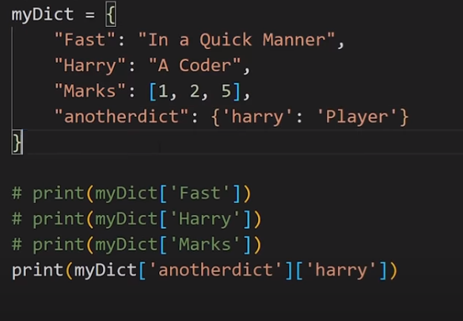

- items() : returns a list of (key,value) tuple.
- keys() : returns a list containing dictionary’s keys.
- update({“friend”: “Sam”}) : updates the dictionary with supplied key-value pairs.
- get(“name”) : returns the value of the specified keys (and value is returned e.g., “Harry” is returned here)
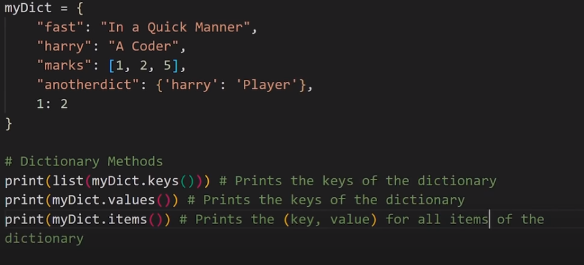
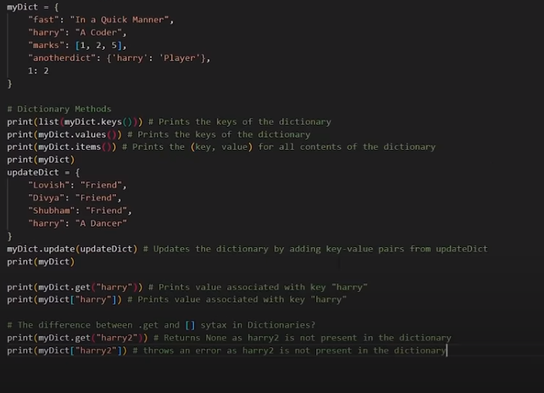
More methods are available on docs.python.org

Sets in Python
Set is a collection of non-repetitive elements.
S= Set() # No repetition allowed!

S.add(1)

S.add(2)

# or Set = {1,2}
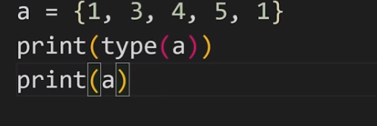
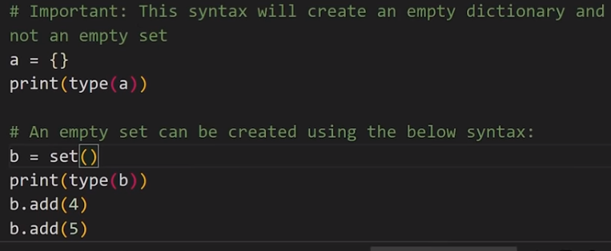

If you are a programming beginner without much knowledge of mathematical operations on sets, you can simply look at sets in python as data types containing unique values.
Properties of Sets
- Sets are unordered # Elements order doesn’t matter
- Sets are unindexed # Cannot access elements by index
- There is no way to change items in sets
- Sets cannot contain duplicate values

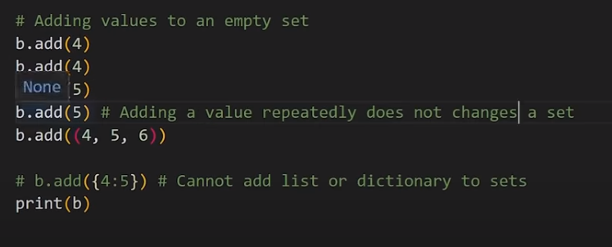

Operations on Sets
Consider the following set:
S = {1,8,2,3}
Copy
- Len(s) : Returns 4, the length of the set
- remove(8) : Updates the set S and removes 8 from S
- pop() : Removes an arbitrary (random) element from the set and returns the element removed.
- clear() : Empties the set S
- union({8, 11}) : Returns a new set with all items from both sets. #{1,8,2,3,11}
- intersection({8, 11}) : Returns a set which contains only items in both sets. #{8}

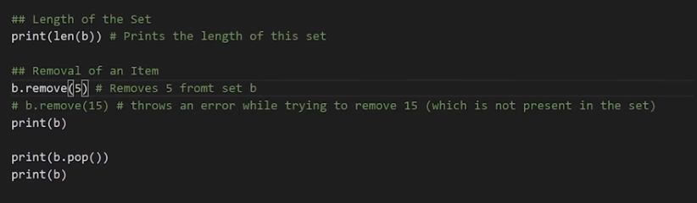
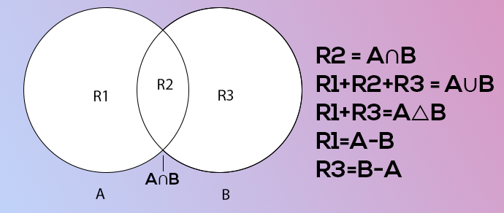
Chapter 5 – Practice Set
- Write a program to create a dictionary of Hindi words with values as their English translation. Provide the user with an option to look it up!
- Write a program to input eight numbers from the user and display all the unique numbers (once).
- Can we have a set with 18(int) and “18”(str) as a value in it?
- What will be the length of the following set S:
S = Set()

S.add(20)

S.add(20.0)

S.add(“20”)
Copy
What will be the length of S after the above operations?
- S = {}, what is the type of S?
- Create an empty dictionary. Allow 4 friends to enter their favorite language as values and use keys as their names. Assume that the names are unique.
- If the names of 2 friends are the same; what will happen to the program in Program 6?
- If the languages of two friends are the same; what will happen to the program in Program 6?
- Can you change the values inside a list which is contained in set S
S = {8, 7, 12, “Harry”, [1, 2]}

Chapter 6 – Conditional Expressions
Sometimes we want to play pubg on our phone if the day is Sunday.
Sometimes we order Ice-cream online if the day is sunny.
Sometimes we go hiking if our parents allow.
All these are decisions that depend on the condition being met.
In python programming too, we must be able to execute instructions on a condition(s) being met. This is what conditions are for!
If else and elif in Python
If else and elif statements are a multiway decision taken by our program due to certain conditions in our code.
Syntax:
'''
if (condition1): // if condition 1 is true
print(“yes”)
elif (condition2): // if condition 2 is true
print(“No”)
else: // otherwise
print(“May be”)
'''
Copy
Code example:
a = 22
if (a>9):
print(“Greater”)
else:
print(“lesser”)
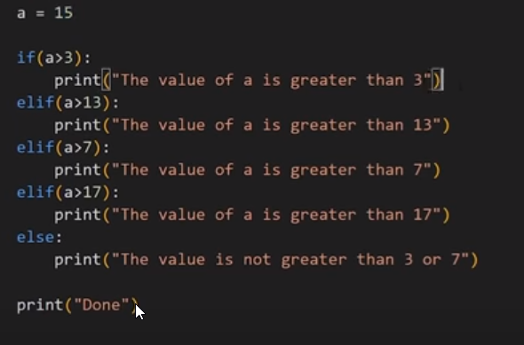

>>> x = 0
>>> y = 5

>>> if x < y: # Truthy
... print('yes')
...
yes
>>> if y < x: # Falsy
... print('yes')
...

>>> if x: # Falsy
... print('yes')
...
>>> if y: # Truthy
... print('yes')
...
yes

>>> if x or y: # Truthy
... print('yes')
...
yes
>>> if x and y: # Falsy
... print('yes')
...

>>> if 'aul' in 'grault': # Truthy
... print('yes')
...
yes
>>> if 'quux' in ['foo', 'bar', 'baz']: # Falsy
... print('yes')
...

Quick Quiz: Write a program to print yes when the age entered by the user is greater than or equal to 18.
Relational Operators
Relational operators are used to evaluate conditions inside if statements. Some examples of relational operators are:
= = -> equals

>= -> greater than/equal to

<=, etc.
Copy
Logical Operators
In python, logical operators operate on conditional statements. Example:
and -> true if both operands are true else false

or -> true if at least one operand is true else false

not -> inverts true to false and false to true
Copy
elif clause
elif in python means [else if]. If statement can be chained together with a lot of these elif statements followed by an else statement.
'''
if (condition1):
#code
elif (condition 2):
#code
elif (condition 2):
#code
….
else:
#code '''
Copy
- The above ladder will stop once a condition in an if or elif is met.
Important Notes:
- There can be any number of elif statements.
- Last else is executed only if all the conditions inside elifs fail.
Chapter 6 – Practice Set
- Write a program to find the greatest of four numbers entered by the user.
- Write a program to find out whether a student is pass or fail if it requires a total of 40% and at least 33% in each subject to pass. Assume 3 subjects and take marks as an input from the user.
- A spam comment is defined as a text containing the following keywords:
“make a lot of money”, “buy now”, “subscribe this”, “click this”. Write a program to detect these spams.
- Write a program to find whether a given username contains less than 10 characters or not.
- Write a program that finds out whether a given name is present in a list or not.
- Write a program to calculate the grade of a student from his marks from the following scheme:
90-100 | Ex
80-90 | A
70-80 | B
60-70 | C
50-60 | D
<50 | F
- Write a program to find out whether a given post is talking about “Harry” or not.

Chapter 7 – Loops in Python
Sometimes we want to repeat a set of statements in our program. For instance: Print 1 to 1000
Loops make it easy for a programmer to tell the computer, which set of instructions to repeat, and how!

a loop is a sequence of instruction s that is continually repeated until a certain condition is reached.
Typically, a certain process is done, such as getting an item of data and changing it, and then some condition is checked such as whether a counter has reached a prescribed number.

Types of loops in Python
Primarily there are two types of loops in Python
- While loop
- For loop
We will look into this one by one!
While loop
The syntax of a while loop looks like this:
''' while condition:
#Body of the loop '''
- The block keeps executing until the condition is true/false
In while loops, the condition is checked first. If it evaluates to true, the body of the loop is executed, otherwise not!
If the loop is entered, the process of condition check and execution is continued until the condition becomes false.
Quick Quiz: Write a program to print 1 to 50 using a while loop.
An Example:
i = 0
while i<5:
print(“Harry”)
i = i+1
Copy
(Above program will print Harry 5 times)
Note: if the condition never becomes false, the loop keeps getting executed.
Quick Quiz: Write a program to print the content of a list using while loops.
For loop
A for loop is used to iterate through a sequence like a list, tuple, or string (iterables)
The syntax of a for loop looks like this:
l = [1, 7, 8]
for item in l:
print(item)
Copy
(Above program will print 1, 7, and 8)
Range function in Python
The range function in python is used to generate a sequence of numbers.
We can also specify the start, stop, and step-size as follows:
range(start, stop, step_size)
- step size is usually not used with range()
An example demonstrating range() function
for i in range(0, 7): #range(7) can also be used
print(i) #prints 0 to 6
Copy
For loop with else
An optional else can be used with a for loop if the code is to be executed when the loop exhausts.
Example:
l = [1, 7, 8]
for item in l:
print(item)
else:
print(“Done”) #This is printed when the loop exhausts!
Copy
Output:
1

7

8

Done
Copy
The break statement
‘break’ is used to come out of the loop when encountered. It instructs the program to – Exit the loop now.
Example:
for i in range(0, 80):
print(i) #This will print 0, 1, 2 and 3
if i == 3:
break
Copy
The continue statement
‘continue’ is used to stop the current iteration of the loop and continue with the next one. It instructs the program to “skip this iteration.”
Example:
for i in range(4):
print(“printing”)
if i == 2: #if i is 2, the iteration is skipped
continue
print(i)
Copy
pass statement
pass is a null statement in python. It instructs to “Do nothing.”
Example:
l = [1, 7, 8]
for item in l:
pass #without pass, the program will throw an error
Copy
Chapter 7 – Practice Set
- Write a program to print the multiplication table of a given number using for loop.
- Write a program to greet all the person names stored in a list l1 and which starts with S.
l1 = [“Harry”, “Sohan”, “Sachin”, “Rahul”]
Copy
- Attempt problem 1 using a while loop.
- Write a program to find whether a given number is prime or not.
- Write a program to find the sum of first n natural numbers using a while loop.
- Write a program to calculate the factorial of a given number using for loop.
- Write a program to print the following star pattern.
*

***

***** for n=3
Copy
- Write a program to print the following star pattern:
*

**

*** for n = 3
Copy
- Write a program to print the following star pattern:
* * *
* * #For n=3
* * *
Copy
10. Write a program to print the multiplication table of n using for loop in reversed order.

Chapter 8 – Functions and Recursions
A function is a group of statements performing a specific task.
When a program gets bigger in size and its complexity grows, it gets difficult for a programmer to keep track of which piece of code is doing what!
A function can be reused by the programmer in a given program any number of times.
Example and Syntax of a function
The syntax of a function looks as follows:
def func1():
print(“Hello”)
Copy
This function can be called any number of times, anywhere in the program.
Function call
Whenever we want to call a function, we put the name of the function followed by parenthesis as follows:
func1() #This is called function call
Copy
Function definition
The part containing the exact set of instructions that are executed during the function call.
Quick Quiz: Write a program to greet a user with “Good day” using functions.
Types of functions in Python
There are two types of functions in Python:
- Built-in functions #Already present in Python
- User-defined functions #Defined by the user
Examples of built-in function includes len(), print(), range(), etc.
The func1() function we defined is an example of a user-defined function.
Functions with arguments
A function can accept some values it can work with. We can put these values in the parenthesis. A function can also return values as shown below:
def greet(name):
gr = “Hello” + name
return gr
Copy
a = greet(“Credence”) # “Credence” is passed to greet in name

# a will now contain “Hello Credence”
Copy
Default Parameter Value
We can have a value as the default argument in a function.
If we specify name = “stranger” in the line containing def, this value is used when no argument is passed.
For Example:
def greet(name=’stranger’):
#function body
Copy
greet() #Name will be ‘stranger’ in function body(default)

greet(“Harry”) #Name will be “Harry” in function body(passed)
Copy
Recursion
Recursion is a function which calls itself.
It is used to directly use a mathematical formula as a function. For example:
factorial(n) = n * factorial(n-1)
Copy
This function can be defined as follows:
def factorial(n):
if i == 0 or i == 1 : #Base condition which doesn’t call the function any further
return i
else:
return n*factorial(n-1) #Function calling itself
Copy
This works as follows:
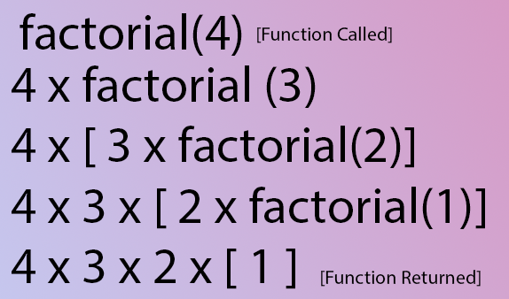
The programmer needs to be extremely careful while working with recursion to ensure that the function doesn’t infinitely keep calling itself.
Recursion is sometimes the most direct way to code an algorithm.
Chapter 8 – Practice Set
- Write a program using the function to find the greatest of three numbers.
- Write a python program using the function to convert Celsius to Fahrenheit.
- How do you prevent a python print() function to print a new line at the end?
- Write a recursive function to calculate the sum of first n natural numbers.
- Write a python function to print the first n lines of the following pattern.
***

** #For n = 3

*
Copy
- Write a python function that converts inches to cms.
- Write a python function to remove a given word from a list and strip it at the same time.
- Write a python function to print the multiplication table of a given number.
Project 1: Snake, Water, Gun Game
We all have played snake, water gun game in our childhood. If you haven’t, google the rules of this game and write a Python program capable of playing this game with the user.

Chapter 9 – File I/O
The random access memory is volatile, and all its contents are lost once a program terminates.
In order to persist the data forever, we use files.
A file is data stored in a storage device. A python program can talk to the file by reading content from it and writing content to it.
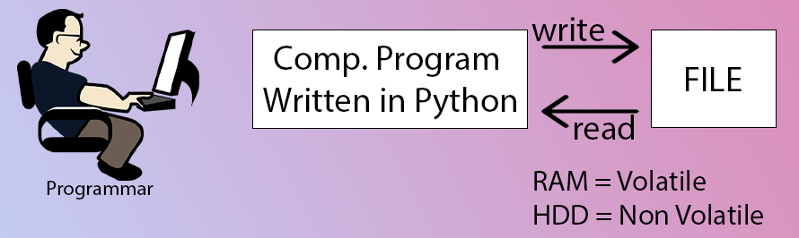
Types of Files
There are 2 types of files:
- Text files (.txt, .c, etc)
- Binary files (.jpg, .dat, etc)
Python has a lot of functions for reading, updating, and deleting files.
Opening a file
Python has an open() function for opening files. It takes 2 parameters: filename and mode.
open(“this.txt”, “r”)
Copy
Here, “this” is the file name and “r” is the mode of opening (read mode)
Reading a file in Python
f = open(“this.txt”, “r”) #Opens the file in r mode

text = f.read() #Read its content

print(text) #Print its contents

f.close() #Close the fie
Copy
We can also specify the number of characters in read() function:
f.read(2) #Reads first 2 characters
Copy
Other methods to read the file
We can also use f.readline() function to read one full line at a time.
f.readline() #Reads one line from the file
Copy
Modes of opening a file
r – open for reading
w – open for writing, creates a new file if it does not exist or truncates the file if it exists.
x - Opens a file for exclusive creation. If the file already exists, the operation fails.
a – Opens a file for appending at the end of the file without truncating it.
Creates a new file if it does not exist.
+ -> Opens a file for updating (reading and writing)
‘rb’ will open for read in binary mode
Writing Files in Python
In order to write to a file, we first open it in write or append mode, after which, we use the python’s f.write() method to write to the file!
f = open(“this.txt”, “w”)

f.write(“This is nice”) #Can be called multiple times

f.close()
Copy
With statement
The best way to open and close the file automatically is the “with” statement.
with open(“this.txt”) as f:

f.read()
Copy
#There is no need to write f.close() as it is done automatically
Chapter 9 – Practice Set
- Write a program to read the text from a given file, “poems.txt” and find out whether it contains the word ‘twinkle’.
- The game() function in a program lets a user play a game and returns the score as an integer. You need to read a file “Hiscore.txt” which is either blank or contains the previous Hi-score. You need to write a program to update the Hi-score whenever game() breaks the Hi-Score.
- Write a program to generate multiplication tables from 2 to 20 and write it to the different files. Place these files in a folder for a 13- year old boy.
- A file contains the word “Donkey” multiple times. You need to write a program which replaces this word with ###### by updating the same file.
- Repeat program 4 for a list of such words to be censored.
- Write a program to mine a log file and find out whether it contains ‘python’.
- Write a program to find out the line number where python is present from question 6.
- Write a program to make a copy of a text file “this.txt.”
- Write a program to find out whether a file is identical and matches the content of another file.
- Write a program to wipe out the contents of a file using python.
- Write a python program to rename a file to “renamed_by_python.txt.”

Chapter 10 – Object-Oriented Programming
Solving a problem by creating objects is one of the most popular approaches in programming. This is called object-oriented programming.
This concept focuses on using reusable code. (Implements DRY principle)
Class
A class is a blueprint for creating objects.
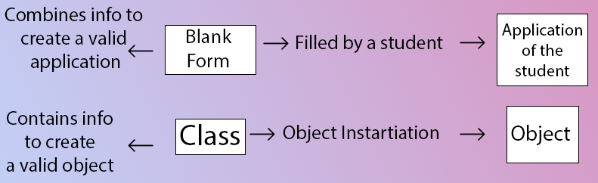
The syntax of a class looks like this:
Class Employee: [classname is written in PascalCase]
#methods & variables
Copy
Object
An object is an instantiation of a class. When class is defined, a template(info) is defined. Memory is allocated only after object instantiation.
Objects of a given class can invoke the methods available to it without revealing the implementation details to the user. #Abstraction & Encapsulation!
Modelling a problem in OOPs
We identify the following in our problem
Noun -> Class -> Employee
Adjective -> Attributes -> name,age,salary
Verbs -> Methods -> getSalary(), increment()
Class Attributes
An attribute that belongs to the class rather than a particular object.
Class attributes are the variables defined directly in the class that are shared by all objects of the class.
Example:
Class Employee:
company = “Google” #Specific to each class
objEmployee = Employee() #Object instantiation
objEmployee.company
Employee.company = “YouTube” #changing class attribute
Copy
Instance Attributes
An attribute that belongs to the Instance (object)
Assuming the class from the previous example:
objEmployee.name = “Harry”
objEmployee.salary = “30K” #Adding instance attributes

Note: Instance attributes take preference over class attributes during assignment and retrieval.
objEmployee.attribute1 :
- Is attribute1 present in the object?
- Is attribute1 present in class?
Class Attribute | Instance Attribute
Defined directly inside a class. | Defined inside a constructor using the self-parameter.
Shared across all objects. | Specific to object.
Accessed using class name as well as using object with dot notation, e.g. classname.class_attribute or object.class_attribute | Accessed using object dot notation e.g. object.instance_attribute
Changing value by using classname.class_attribute = value will be reflected to all the objects. | Changing value of instance attribute will not be reflected to other objects.

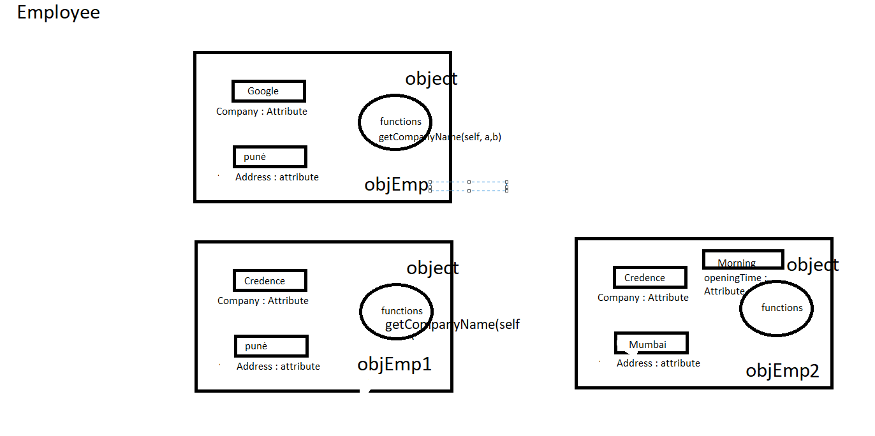

‘self’ parameter
self refers to the instance of the class.
It is automatically passed with a function call from an object.
harry.getSalary()
Copy
here, self is harry, and the above line of code is equivalent to Employee.getSalary(harry)
This function getsalary is defined as:
class Employee:
company = “Google”
def getSalary(self):
print(“Salary is not there”)
Copy
Static method
Static methods, much like class methods, are methods that are bound to a class rather than its object.
They do not require a class instance creation. So, they are not dependent on the state of the object.
The difference between a static method and a class method is:
- Static method knows nothing about the class and just deals with the parameters.
- Class method works with the class since its parameter is always the class itself.
They can be called both by the class and its object.
@staticmethod #decorator to mark greet as a static method
def greet():
print(“Hello user”)

__init__() constructor
__init__() is a special method which runs as soon as the object is created.
__init__() method is also known as constructor.
It takes self-argument and can also take further arguments.

The task of constructors is to initialize(assign values) to the data members of the class when an object of the class is created. In Python the __init__() method is called the constructor and is always called when an object is created.
For Example:
class Employee:
def __init__(self,name):
self.name = name
def getSalary(self):
#Some code…
harry = Employee(“Harry”) #Object can be instantiated using constructor like this!

Types of constructors:
- default constructor: The default constructor is a simple constructor which doesn’t accept any arguments. Its definition has only one argument which is a reference to the instance being constructed.
# default constructor
def __init__(self):
self.name = "Credence"

# creating object of the class
obj = GeekforGeeks()

- parameterized constructor: constructor with parameters is known as parameterized constructor. The parameterized constructor takes its first argument as a reference to the instance being constructed known as self and the rest of the arguments are provided by the programmer.

class Addition:
first = 0
second = 0
answer = 0

# parameterized constructor
def __init__(self, f, s):
self.first = f
self.second = s

# creating object of the class
# this will invoke parameterized constructor
obj = Addition(1000, 2000)

Chapter 10 – Practice Set
- Create a class programmer for storing information of a few programmers working at Microsoft.
- Write a class calculator capable of finding square, cube, and the square root of a number.
- Create a class with a class attribute a; create an object from it and set a directly using object.a=0 Does this change the class attribute?
- Add a static method in problem 2 to greet the user with hello.
- Write a class Train which has methods to book a ticket, get status(no of seats), and get fare information of trains running under Indian Railways.
- Can you change the self parameter inside a class to something else (say ‘harry’)? Try changing self to ‘slf’ or ‘harry’ and see the effects.
Chapter 11 – Inheritance & more on OOPs
Inheritance is a way of creating a new class from an existing class.
Syntax:
class Emoloyee: #Base Class
#Code
class Programmer(Employee): #Derived or child class
#Code
Copy
We can use the methods and attributes of Employee in Programmer object.
Also, we can overwrite or add new attributes and methods in the Programmer class.
Type of Inheritance
- Single inheritance
- Multiple inheritance
- Multilevel inheritance
Single Inheritance
Single inheritance occurs when a child class inherits only a single parent class.
Base -> Derived
Multiple Inheritance
Multiple inheritances occurs when the child class inherits from more than one parent class.
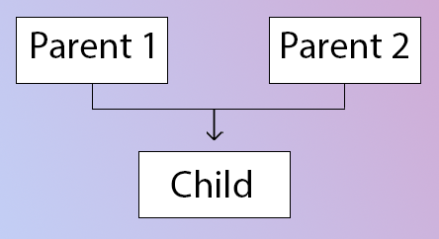
Multilevel Inheritance
When a child class becomes a parent for another child class.
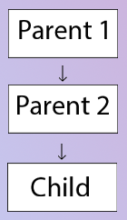
Super() method
Super method is used to access the methods of a superclass in the derived class.
super().__init__() #Calls constructor of the base class
Copy
Class methods
A class method is a method which is bound to the class and not the object of the class.
@classmethod decorator is used to create a class method.
Syntax to create a class method:
@classmethod
def (cls, p1, p2):
#code
Copy
@property decorators
Consider the following class
class Employee:
@property
def name(self):
return self.ename
Copy
if e = Employee() is an object of class employee, we can print (e.name) top print the ename/call name() function.
@.getters and @.setters
The method name with @property decorator is called getter method.
We can define a function + @name.setter decorator like below:
@name.setter
def name(self, value):
self.ename = value
Copy
Operator overloading in Python
Operators in python can be overloaded using dunder methods.
These methods are called when a given operator is used on the objects.
Operators in python can be overloaded using the following methods:
p1 + p2 -> p1.__add__(p2)

p1 – p2 -> p1.__sub__(p2)

p1 * p2 -> p1.__mul__(p2)

p1 / p2 -> p1.__truediv__(p2)

p1 // p2 -> p1.__floordiv__(p2)
Copy
Other dunder/magic methods in Python
__str__() -> used to set what gets displayed upon calling str(obj)

__len__() -> used to set what gets displayed upon calling .__len__() or len(obj)
Copy
Chapter 11 – Practice Set
- Create a class C-2d vector and use it to create another class representing a 3-d vector.
- Create a class of pets from a class Animals and further create class Dog from Pets. Add a method bark to class Dog.
- Create a class Employee and add salary and increment properties to it.
Write a method SalaryAfterIncrement method with a @property decorator with a setter which changes the value of increment based on the salary.
- Write a class complex to represent complex numbers, along with overloaded operators + and * which adds and multiplies them.
- Write a class vector representing a vector of n dimension. Overload the + and * operator which calculates the sum and the dot product of them.
- Write __str__() method to print the vector as follows:
7i + 8j + 10k
Copy
Assume vector of dimension 3 for this problem.
- Override the __len__() method on vector of problem 5 to display the dimension of the vector.
Project 2: Snake, Water, Gun Game
We are going to write a program that generates a random number and asks the user to guess it.
If the player’s guess is higher than the actual number, the program displays “Lower number please”. Similarly, if the user’s guess is too low, the program prints “higher number please”.
When the user guesses the correct number, the program displays the number of guesses the player used to arrive at the number.
Hint: Use the random module

